EXPERIMENT – 1
Create a simple cloud software application and provide it as a service using any Cloud Service Provider to demonstrate Software as a Service (SaaS).
AIM: To create and provide a simple cloud-based software application using Zoho Creator to demonstrate the Software as a Service (SaaS) model.
PROCEDURE:
- Open a web browser and go to Zoho Creator website.
- Create a Zoho account and log in.
- Click on Create Application and select From Scratch.
- Choose Blank App and provide the application name as Hospital.
- Create a form named Patient Details and add fields such as Name, Phone, Date of Birth, Time, Address, Admission number, Email and Gender.
- Mark the necessary fields as mandatory.
- Save the completed form and alter the visual themes.
- Configure user access and sharing settings to allow multiple users to use the application.
- Save the application and generate the application URL.
- Access the application through the URL using any web browser.
OUTPUT:
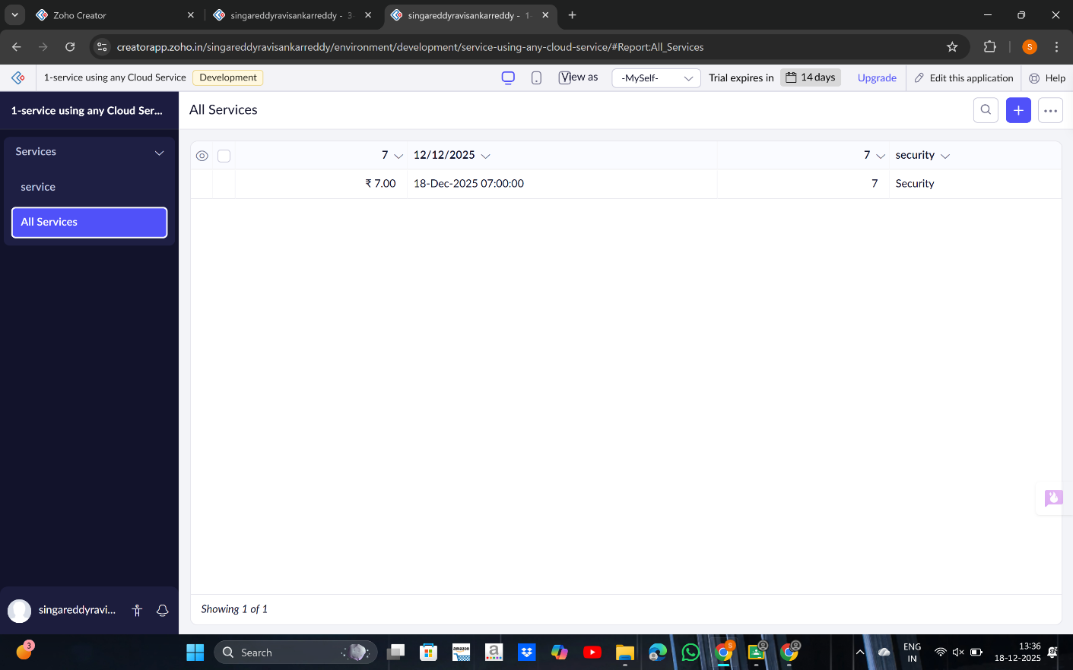

RESULT:
A cloud-based Hospital Admission application was successfully created and deployed using Zoho Creator. The application is accessible through a web browser without installation, and hospital can handle patient details hassle free, thereby successfully demonstrating the Software as a Service (SaaS) model.

